PHOTO TRANSISTOR
光 電 晶 體
Part Number: KO-TNS151
Package outlines
NOTES:
- All dimensions are in millimeters (inches);
2. Tolerances are ±0.1mm (0.004inch) unless otherwise noted.
RECOMMEND PAD LAYOUT
ITEM | MATERIALS
Resin (mold) | Epoxy
Bonding Wire | ✵ 30 μm Au
Lens color | Water transparent
Printed circuit board | BT (white)
Dice | Silicon

PHOTO TRANSISTOR
光 電 晶 體
Part Number: KO-TNS151
Absolute maximum ratings (TA=25℃)
Parameter | Symbol | Value |  |  |  | Unit
Power dissipation | P_{D} | 100 |  |  |  | mW
Collector-emitter voltage | V_{CEO} | 30 |  |  |  | V
Emitter-collector voltage | V_{ECO} | 5 |  |  |  | V
Operating temperature range | T_{OP} | -20 ~+80 |  |  |  | ℃
Storage temperature range | T_{STG} | -20 ~+80 |  |  |  | ℃
Electro-optical characteristics (T_{A}=25℃)
Parameter | Test  Condition | Symbol | Value |  |  |  | Unit
Parameter | Test  Condition | Symbol | Min | Typ | Max |  | Unit
Collector-emitter breakdown voltage | I_{C} = 100µA  I _{B}= 0 | BV _{CEO} | 10 | -- | -- |  | V
Emitter-collector breakdown voltage | I_{E}= 100µA  I _{B}= 0 | BV_{ECO} | 5 | -- | -- |  | V
Collector dark current | V_{CE} = 10V  H = 0mW/cm² | I_{CEO} | -- | -- | 100 |  | nA
Collector-emitter saturation voltage | I_{C}=2 mA  I _{B}=100µA | V_{CE (S)} | -- | -- | 0.3 |  | V
Current gain | V_{CE} = 5V  IC=2mA | hFE | 200 | -- | -- |  | --
7-2
Soldering iron
Basic spec is  5sec when 260℃. If temperature is higher, time should be shorter
(+10℃→ -1sec ).Power dissipation of iron should be smaller than 20W, and temperatures should be controllable .Surface temperature of the device should be under 230℃ .
■ Reflow Temp/Time
Rework
- Customer must finish rework within 5 sec under 260℃.
- The head of iron can not touch copper foil
- Twin-head type is preferred.
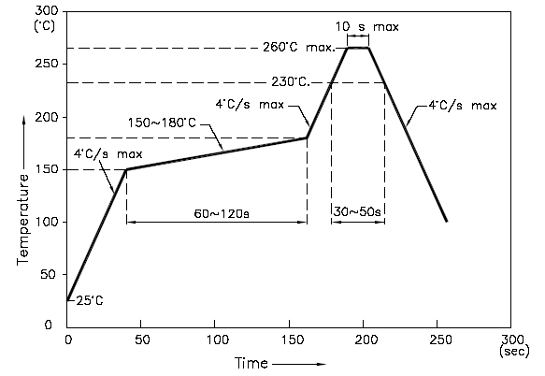
NOTES:
- We recommend the reflow temperature 245℃(±5℃).the maximum soldering temperature should be limited to 260℃.
- dont cause stress to the epoxy resin while it is exposed to high temperature.
- Number of reflow process shall be 2 times or less.
■ Avoid rubbing or scraping the resin by any object, during high temperature, for example reflow 、solder etc.
7-3
7-4
■ Handling precautions
1. Over-current-proof
Customer must apply resistors for protection; otherwise slight voltage shift will cause
big current change (Burn out will happen).

2.Storage
2.1 It is recommended to store the products in the following conditions:
Humidity: 60% R.H. Max.
Temperature : 5℃~30℃(41℉~86℉)
  - Shelf life in sealed bag: 12 month at ＜5℃~30℃ and ＜30% R.H. after the package is
Opened, the products should be used within a week or they should be keeping to stored at
≦20 R.H. with zip-lock sealed.

3.Baking
It is recommended to baking before soldering when the pack is unsealed after 72hrs. The
Conditions are as followings:
3.1 60±3℃ x(12~24hrs) and ＜5%RH, taped reel type
3.2 100±3℃ x(45min~1hr), bulk type
3.3 130±3℃ x(15~30min), bulk type

PHOTO TRANSISTOR
光 電 晶 體

Test items and results of reliability
Type | Test Item | Test Conditions | Device  Hours/Cycle | Device  Tested | Failures
1 | Temperature Cycle | -20℃ 30min  50min↑↓100min  80℃ 30min | 50 cycle | 22 | 0
2 | Thermal Shock | -20℃ 15min  ↑↓  80℃ 15min | 50 cycle | 22 | 0
3 | High Temperature  High Humidity Test | T_{a}=85℃  RH 85% | 1000 hrs | 22 | 0
4 | High Temperature  Storage | T_{a}=80℃ | 1000 hrs | 22 | 0
5 | Low Temperature  Storage | T_{a}= -30℃ | 1000 hrs | 22 | 0
6 | DC Operating Life | V_{CE} = 5V  T_{a}= 25℃  Ee=1mW/cm² | 1000 hrs | 22 | 0

